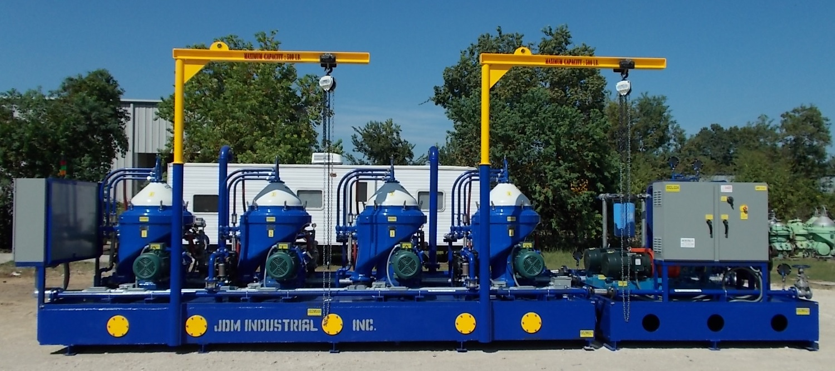

Diesel Fuel Treatment System

